Scenario 3: Order-to-Cash & Overdue Receivables Management
- OBD2 – CREATES CUTOMER GROUP
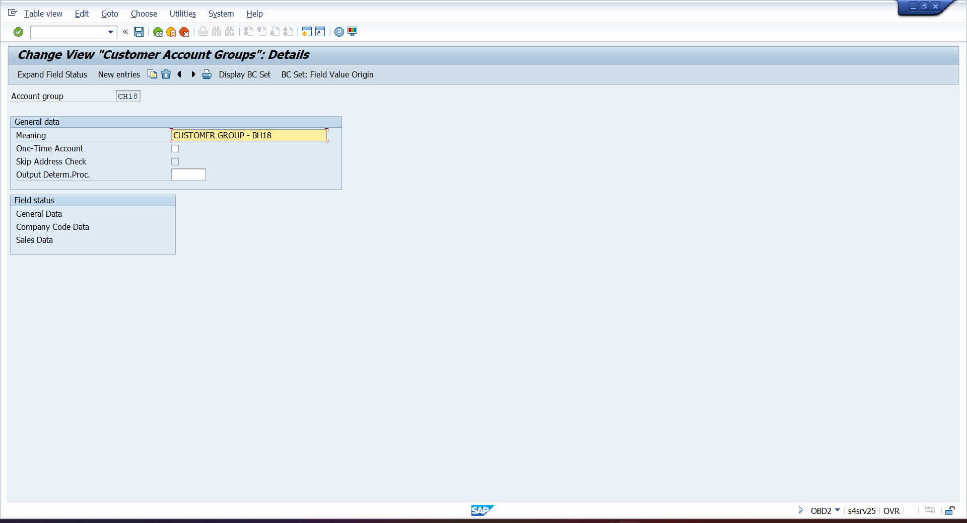

- OBAR – ASSIGN NUMBER RANGE TO CUSTOMER GROUP
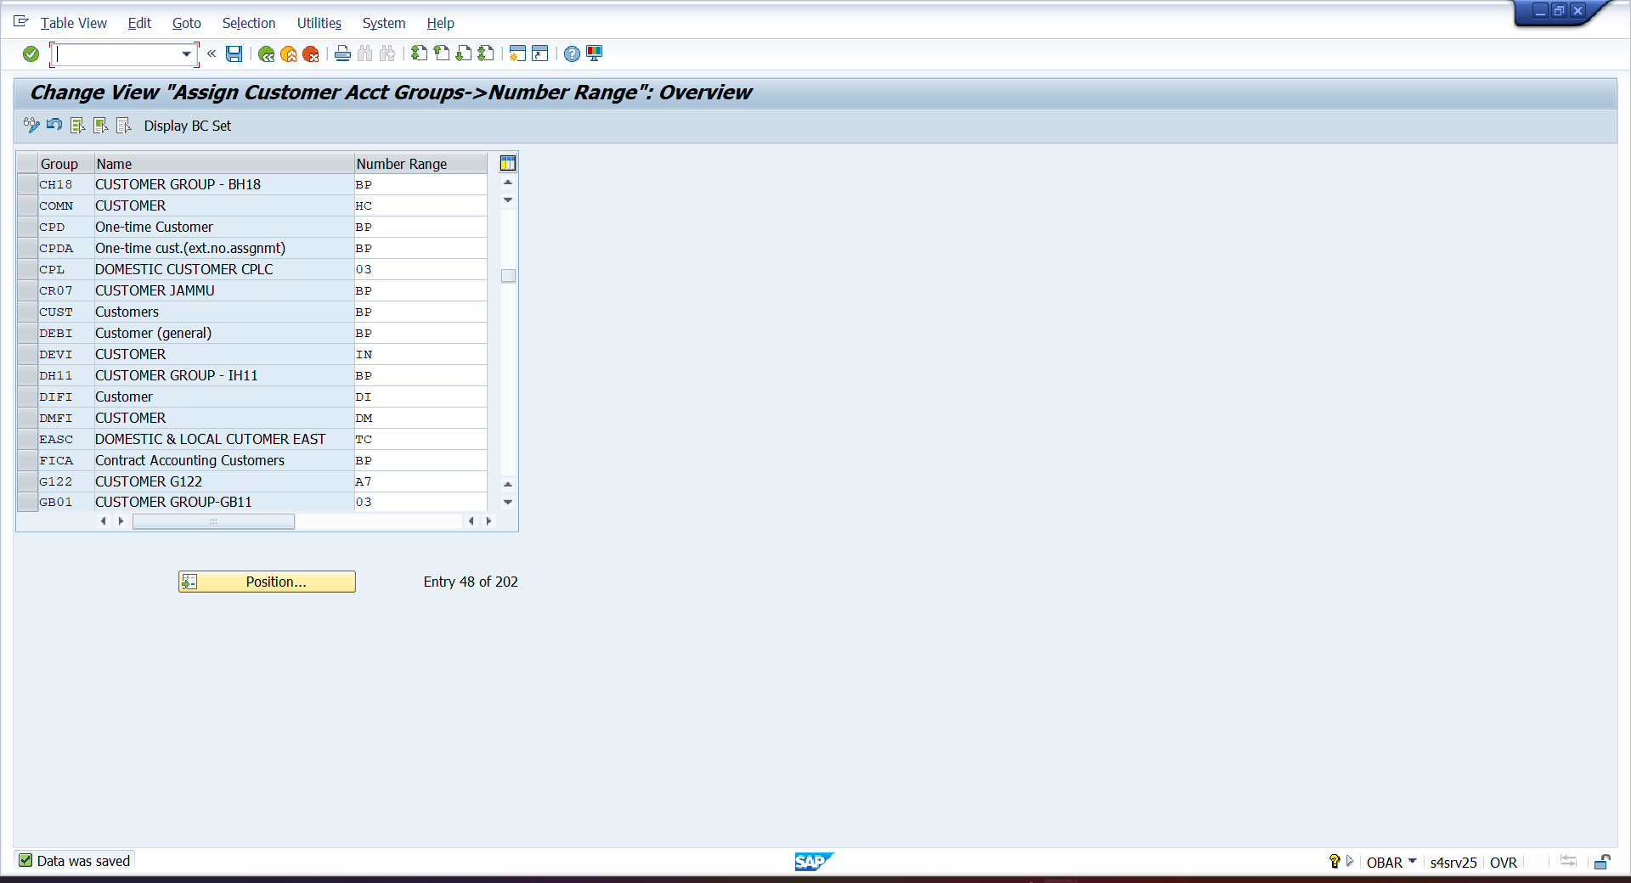

- SPRO—IMG—CROSS APPLICATIO COMP—MASTERDATA SYC—CUTOMER /VENDOR INTEGRAION—BUSINESS PATNER SETTING—SETTING FOR CUSTOMER INTEGRATION—FIELD ASSIGNMENT CUSTOMER —ASSIGN KEY—DEFINE NO. ASSIGNMENT FOR BP – assign group to BP
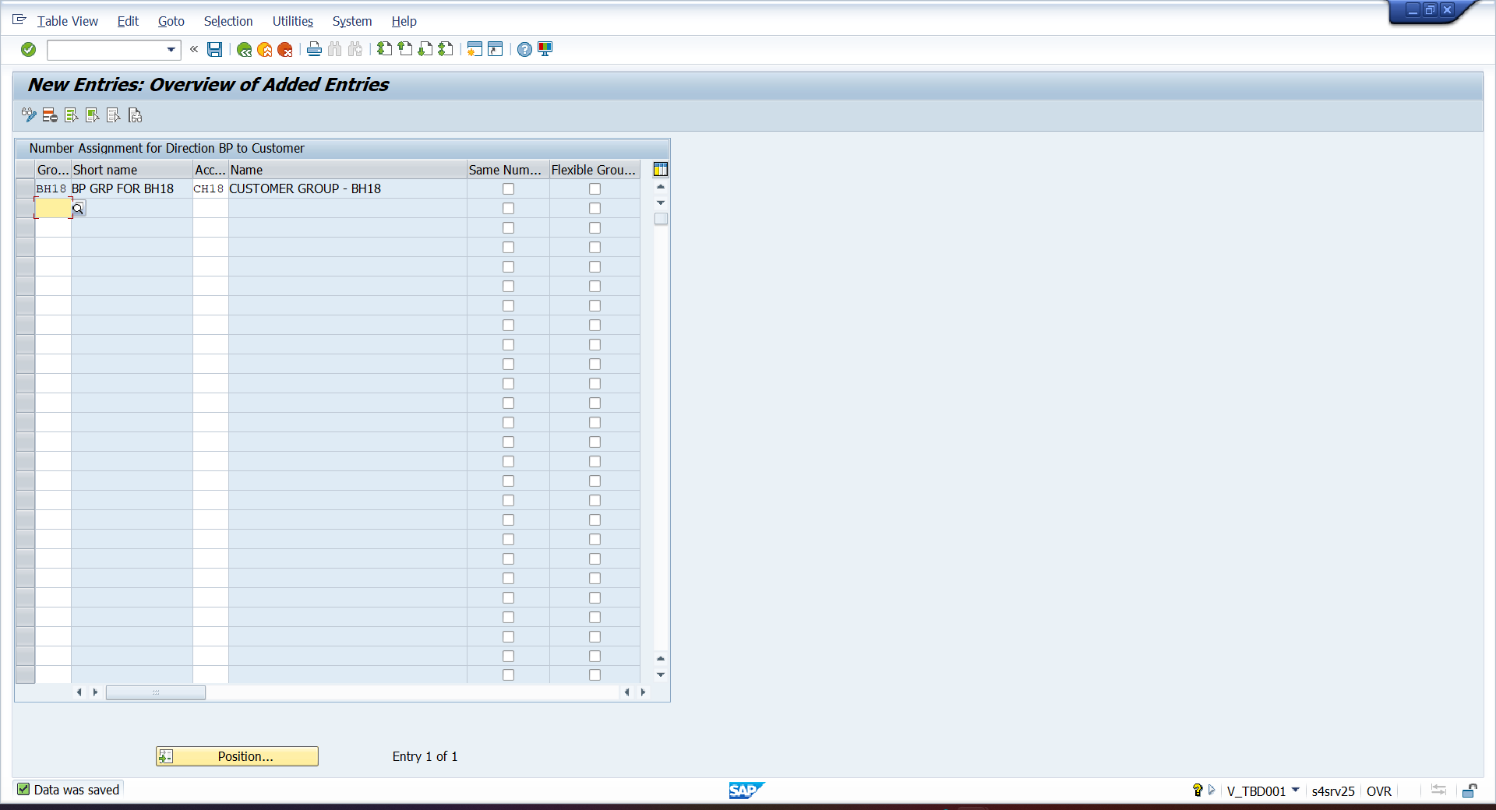

- FS00 – CREATE DEBTORS G/L
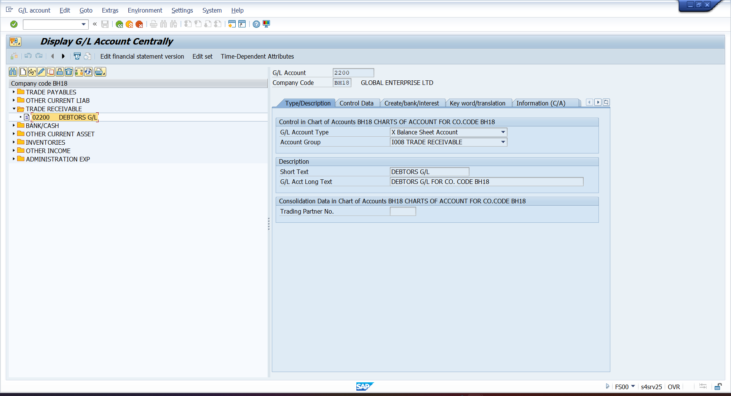

- BP – CREATE CUSTOMER BP
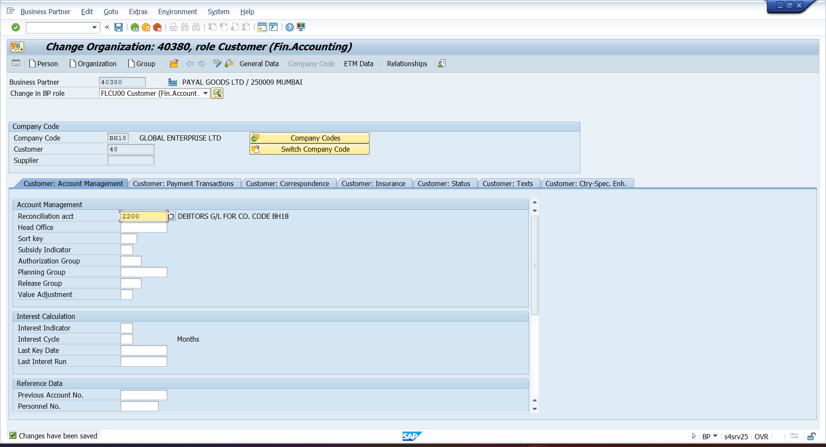
- BP
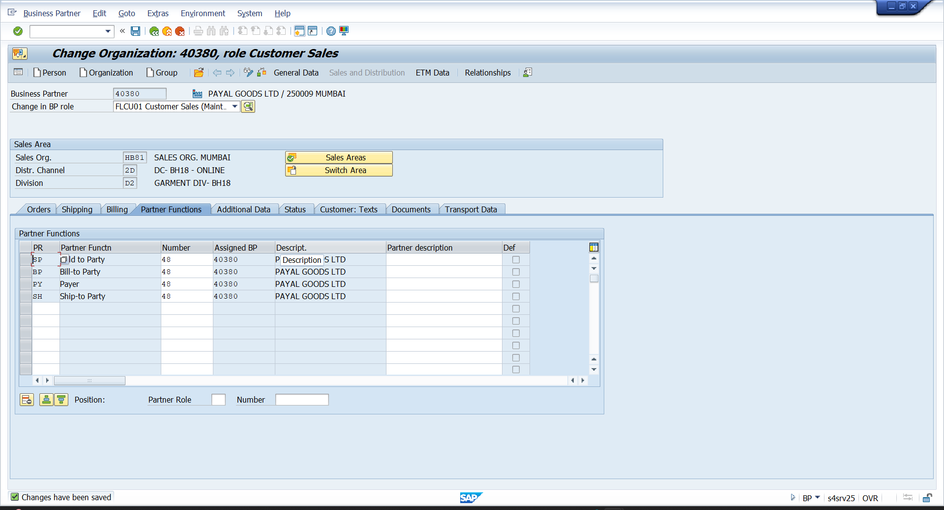

- VOK0
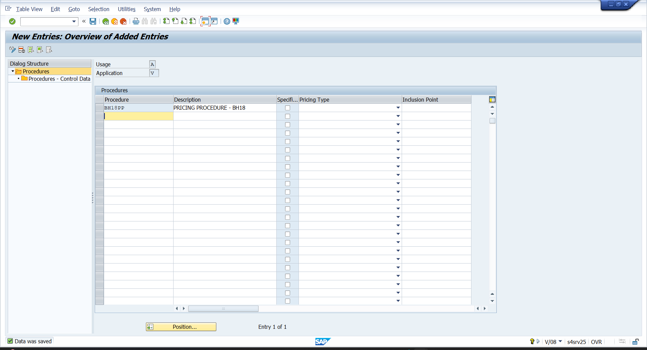

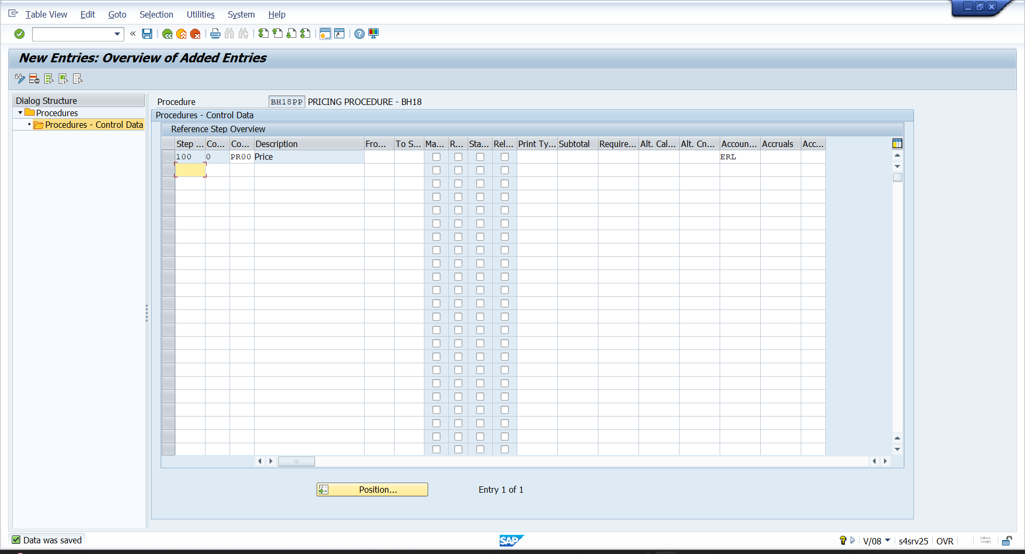

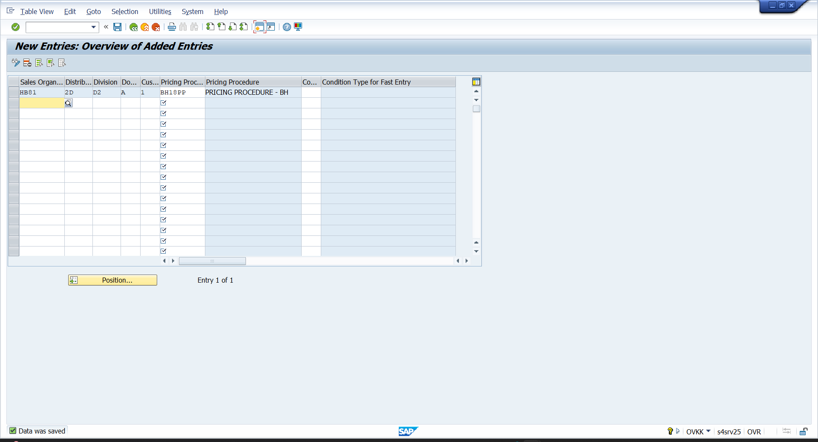
- VK13
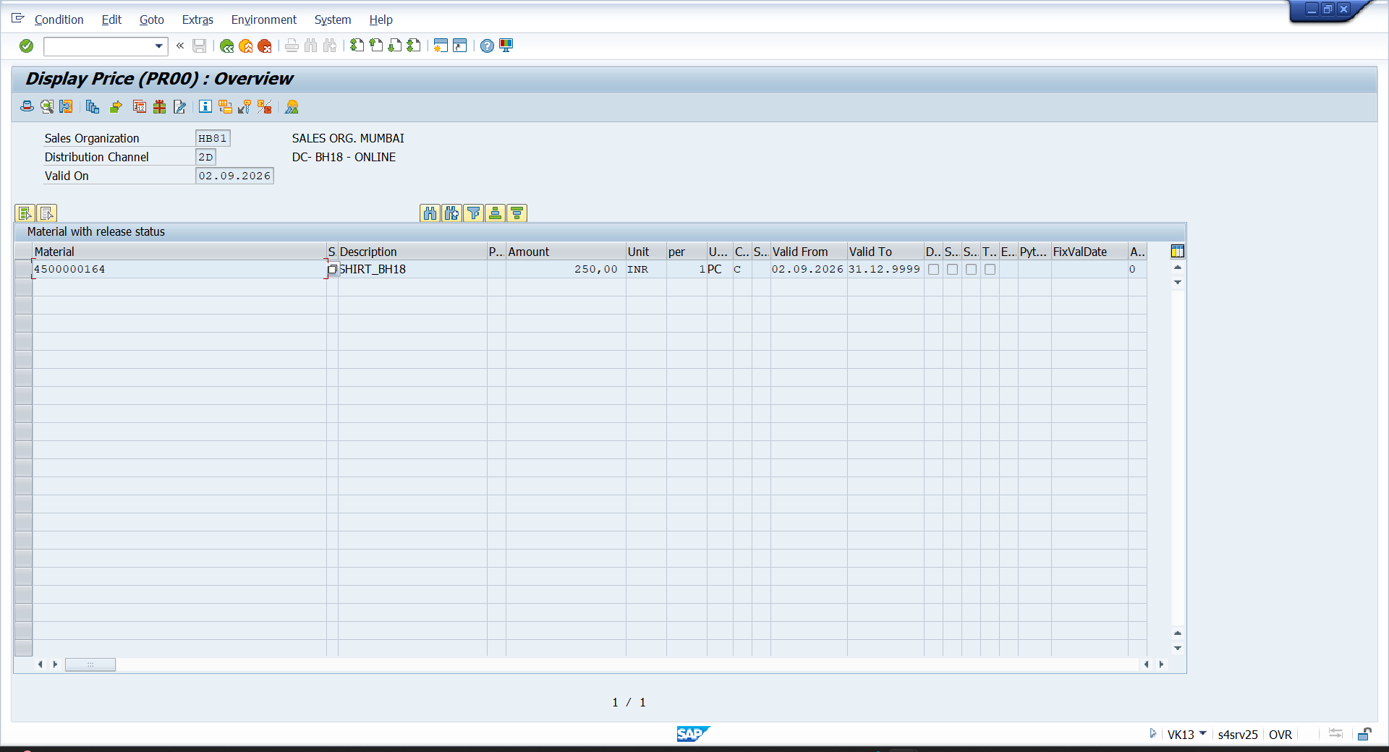

- FS00
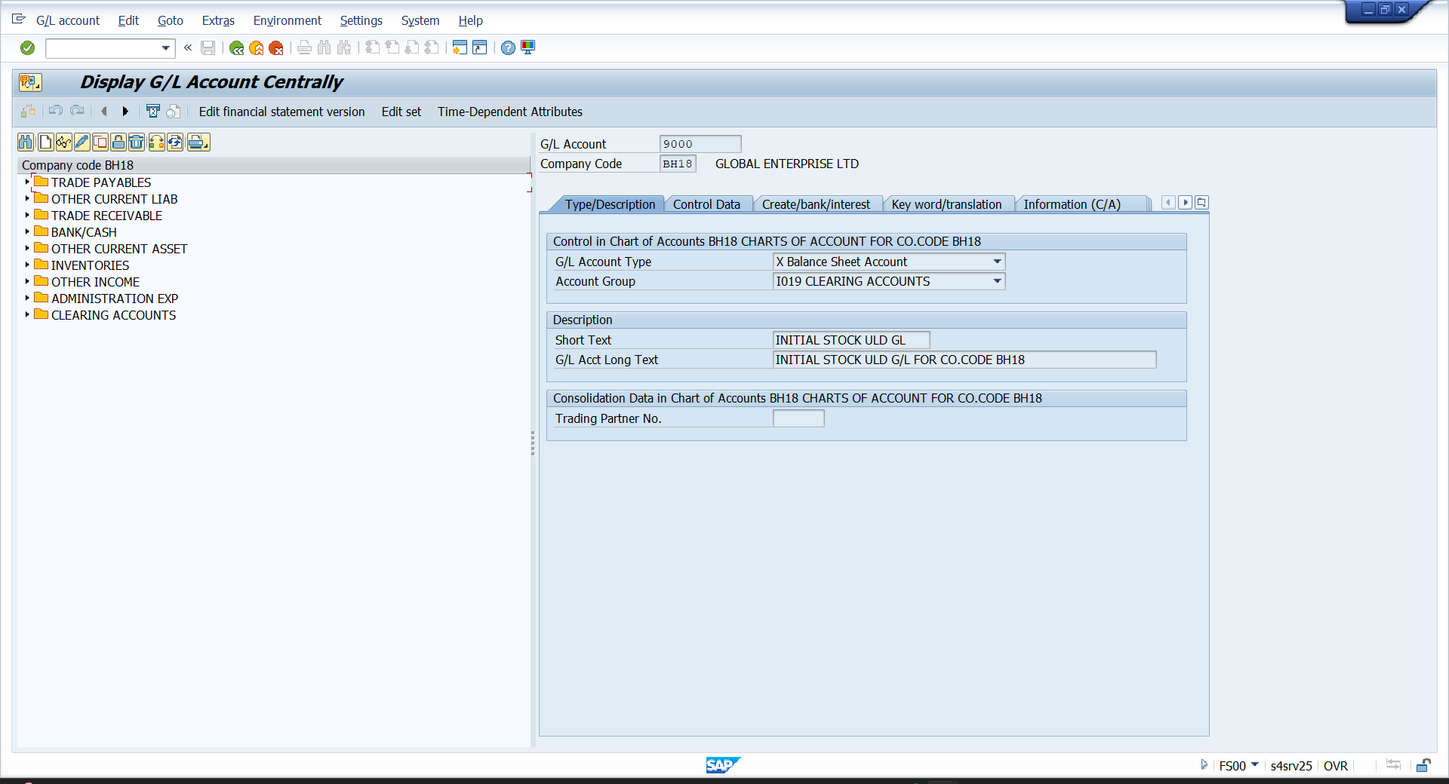
- OBYC
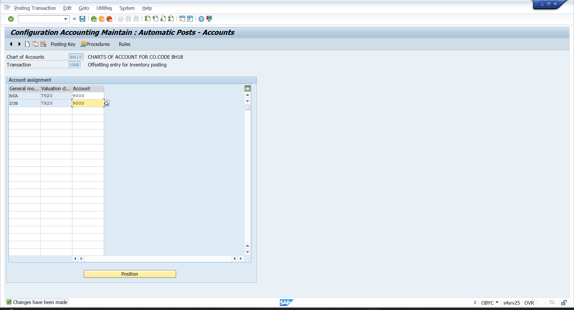

- MM01 – CREATE MATERIAL
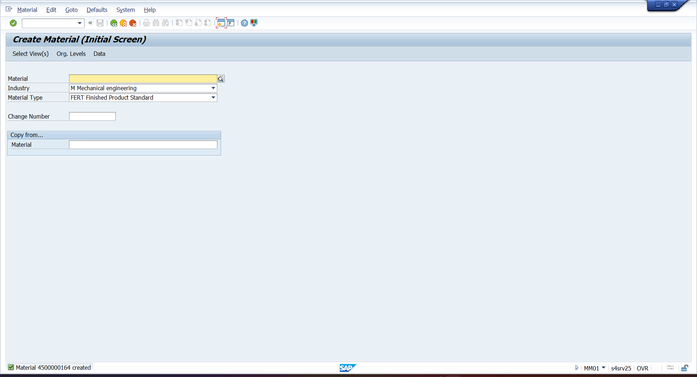

- OBYC – ASSIGN VALUATION CLASS TO G/L
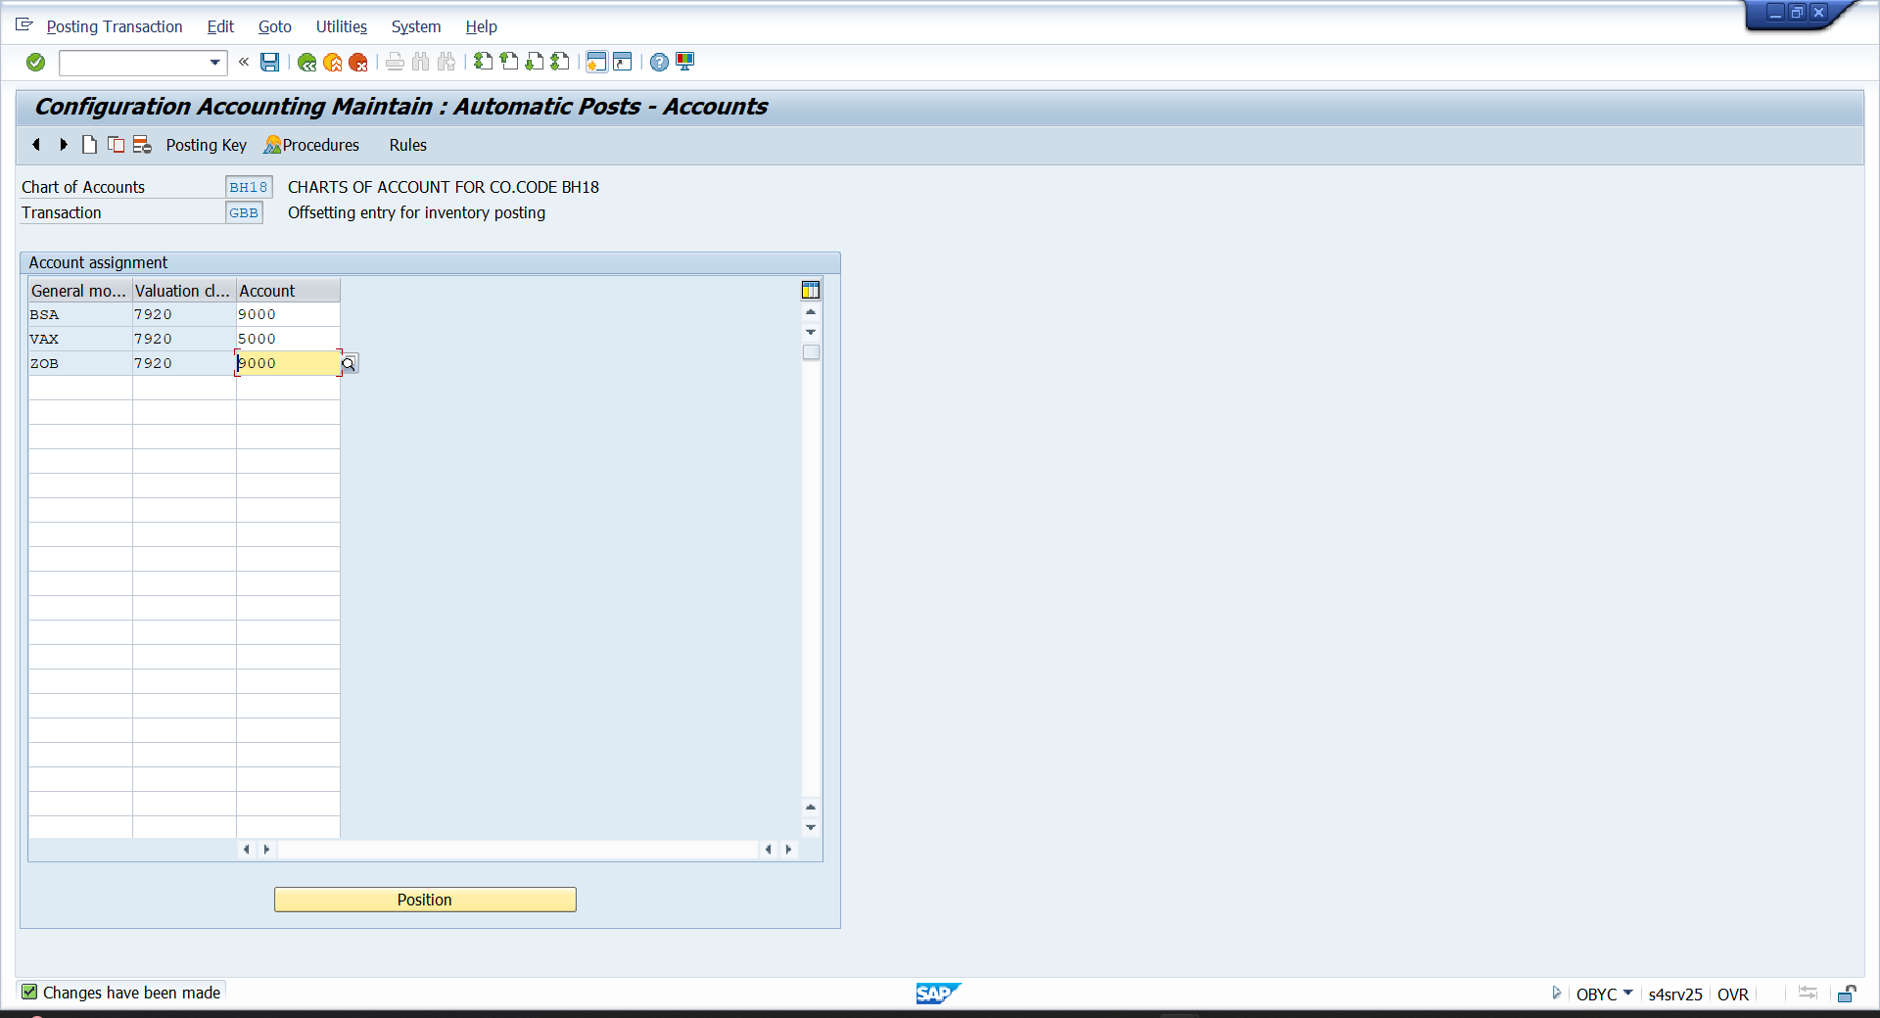

- OKB9 – ASSIGN COST CENTER
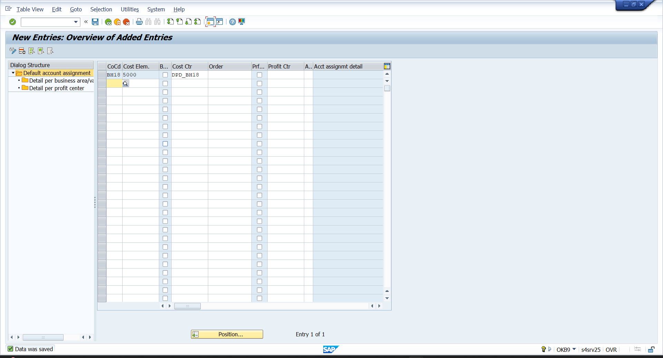

- VKOA- ASSIGN ACCOUNTING KEY
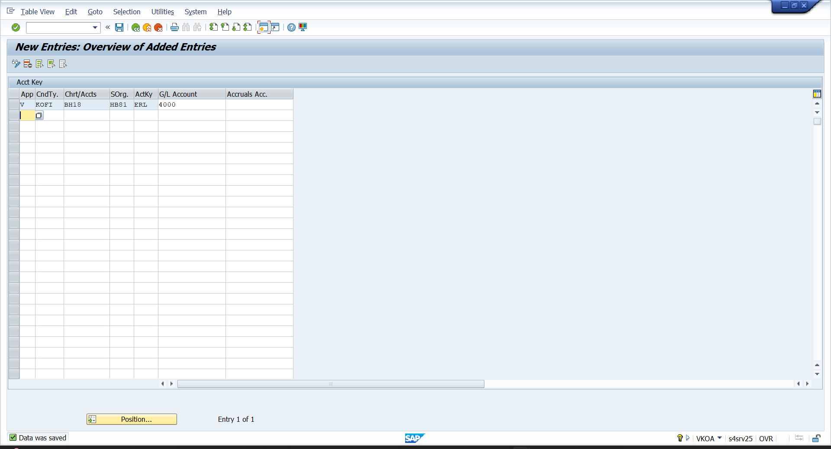

- MIGO – UPLOAD STOCK
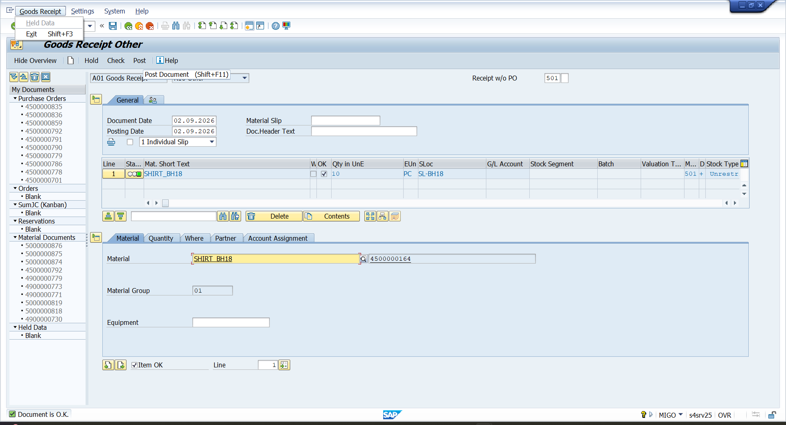

- FS00 – CREATE CUTOMER ADVANCE G/L
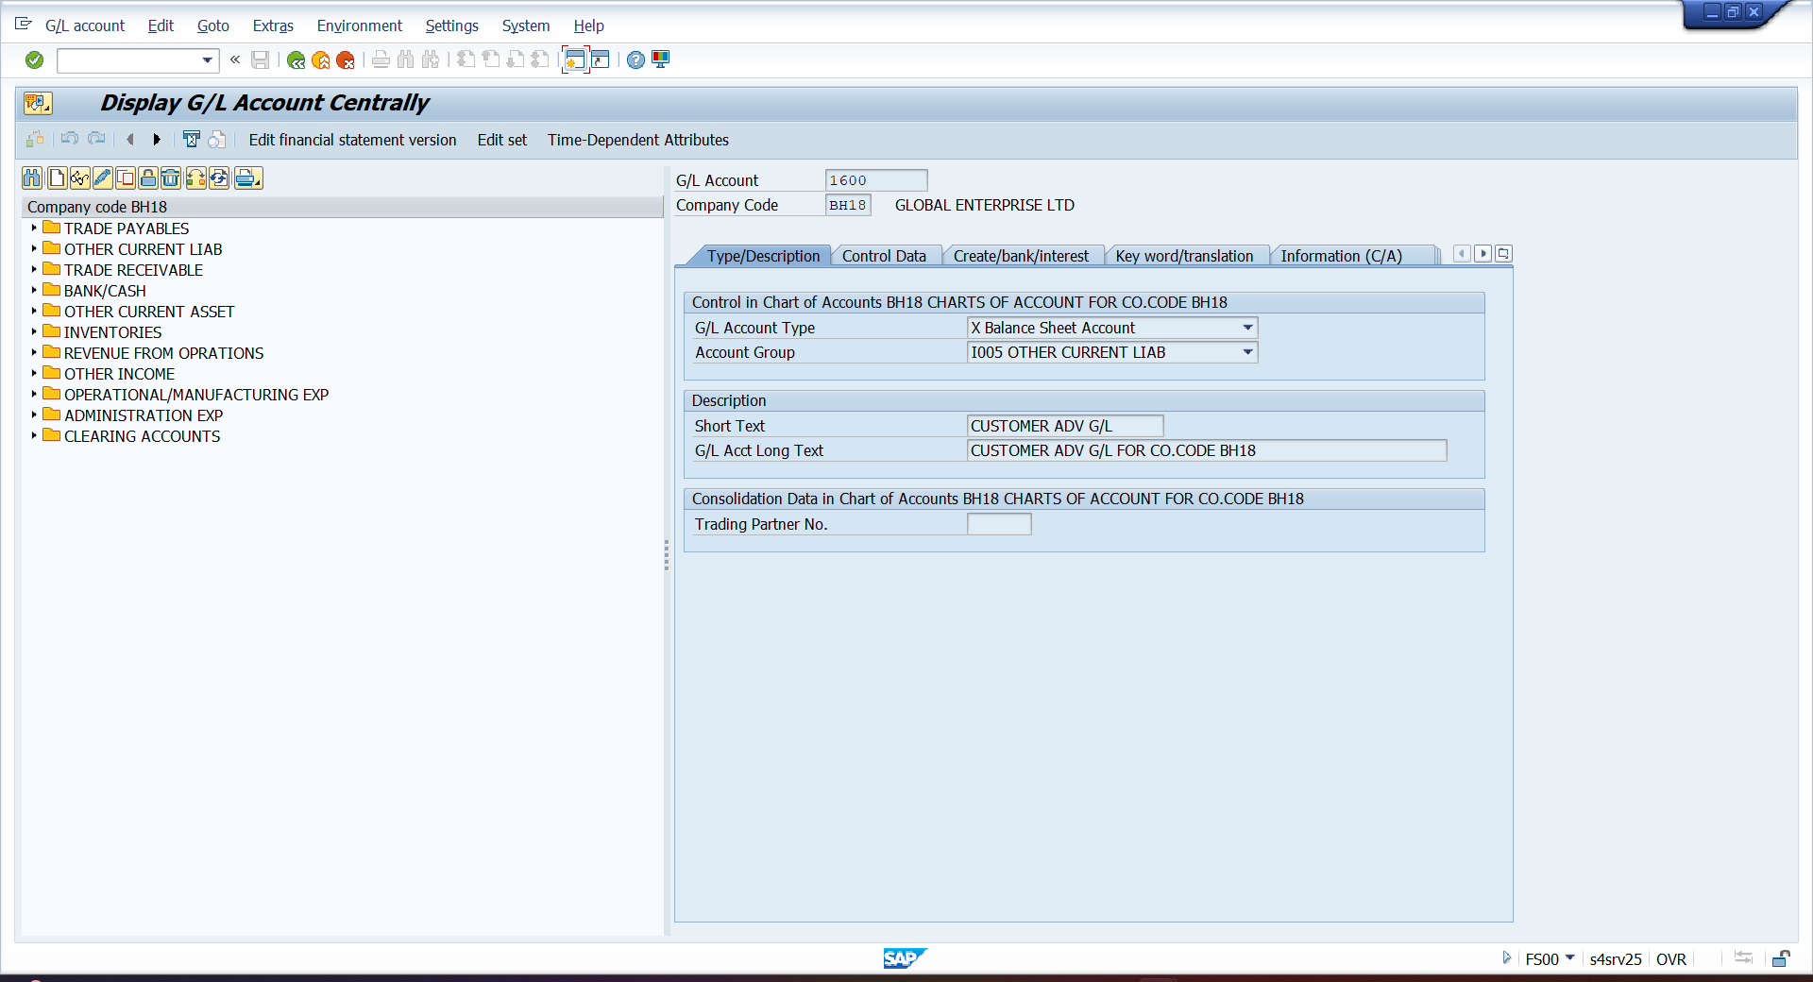

- OBXR – SPECIAL G/L INDICATOR
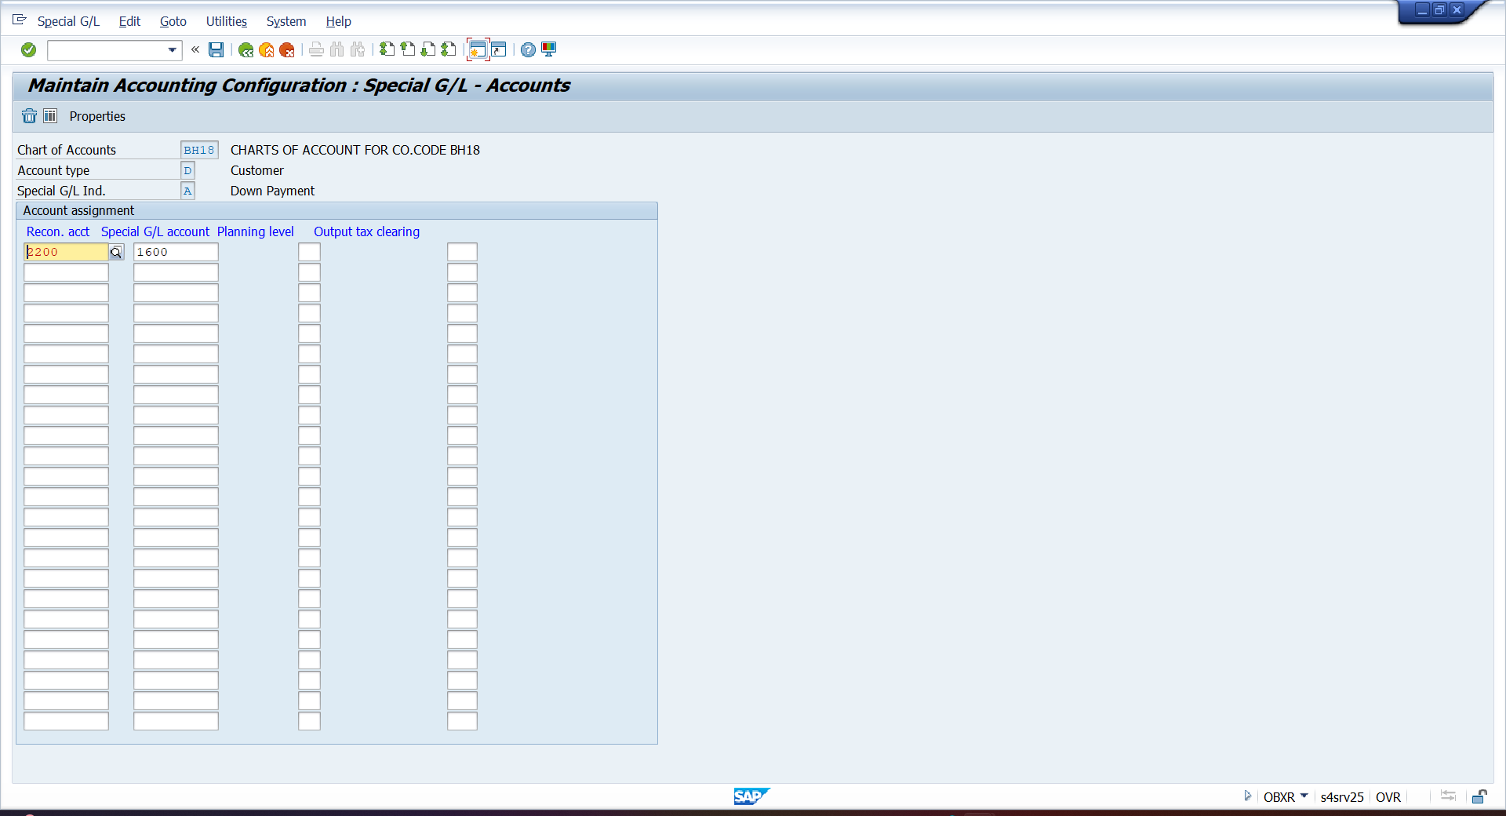

- F-29- CUSTOMER ADVNACE PAYMENT INVOICE
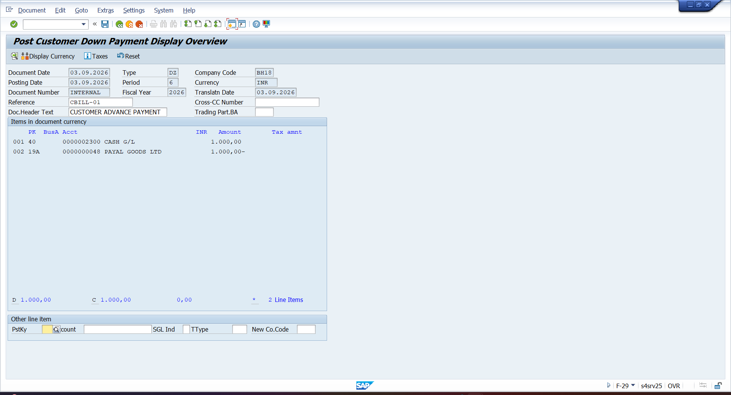

- VA01 – CREATION SALES ORDER
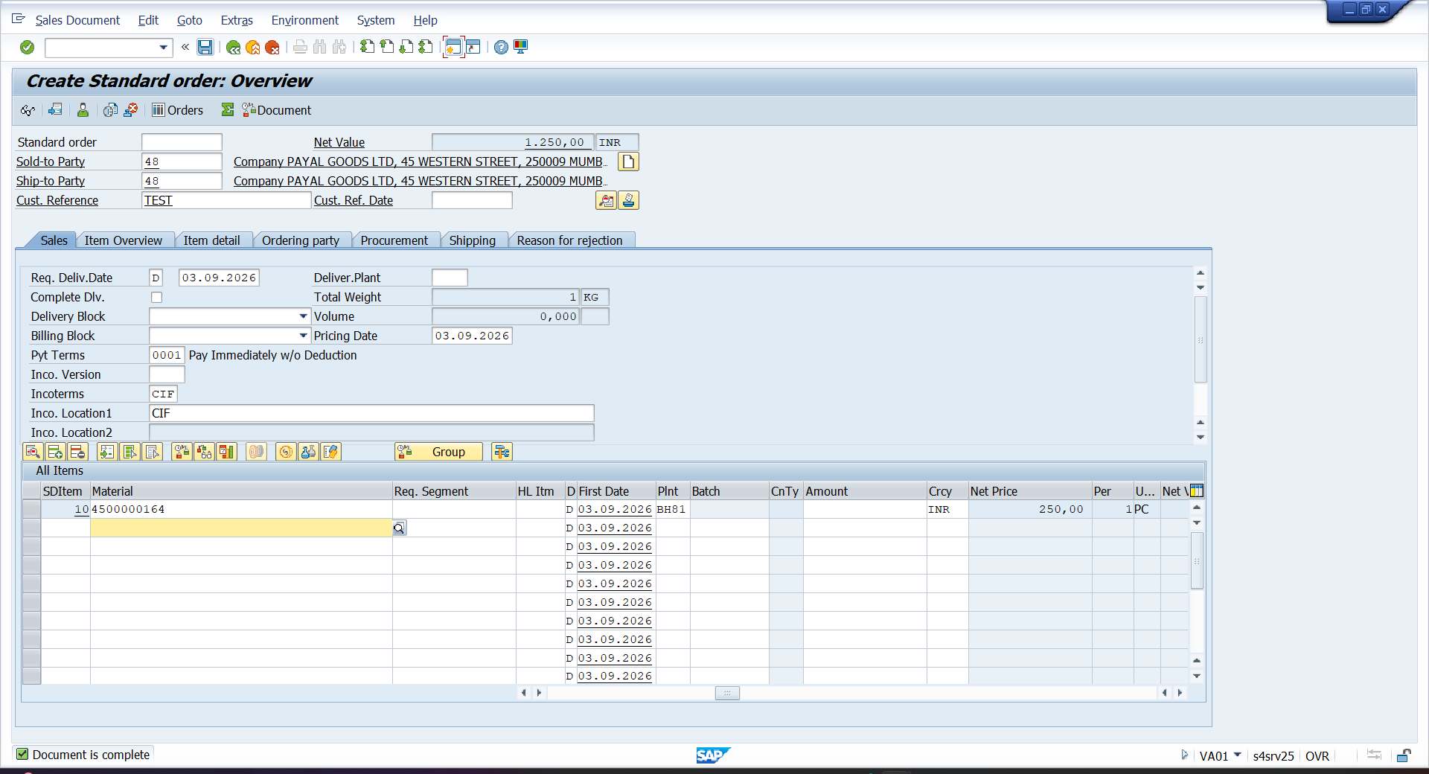

- VL01N – GOODS ISSUES
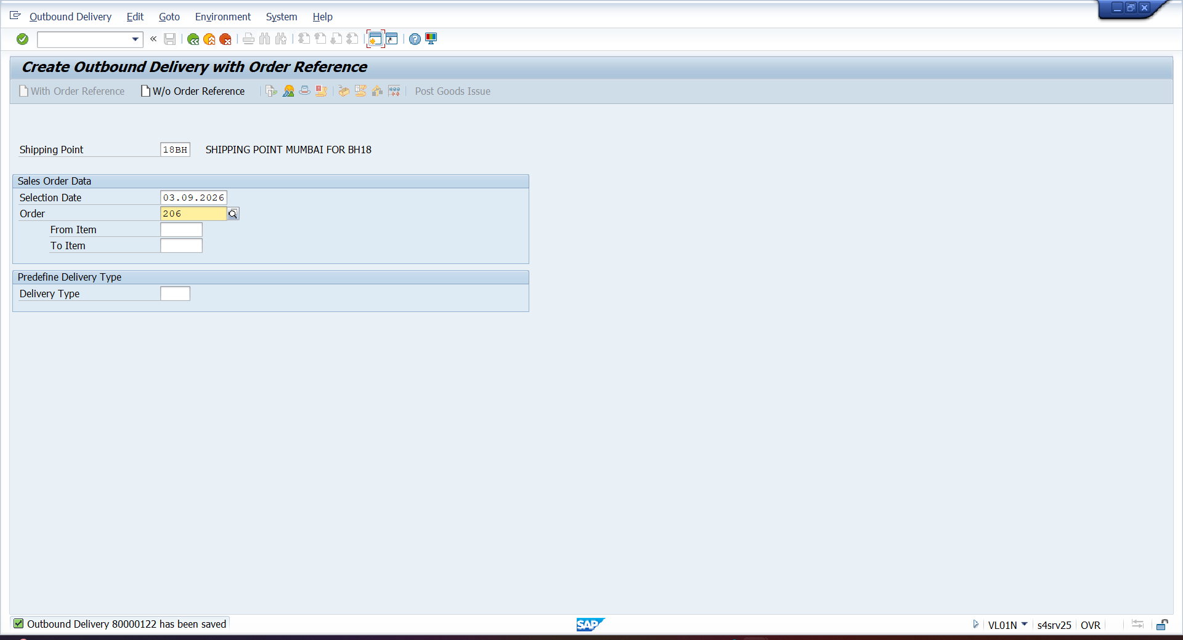

- FB03
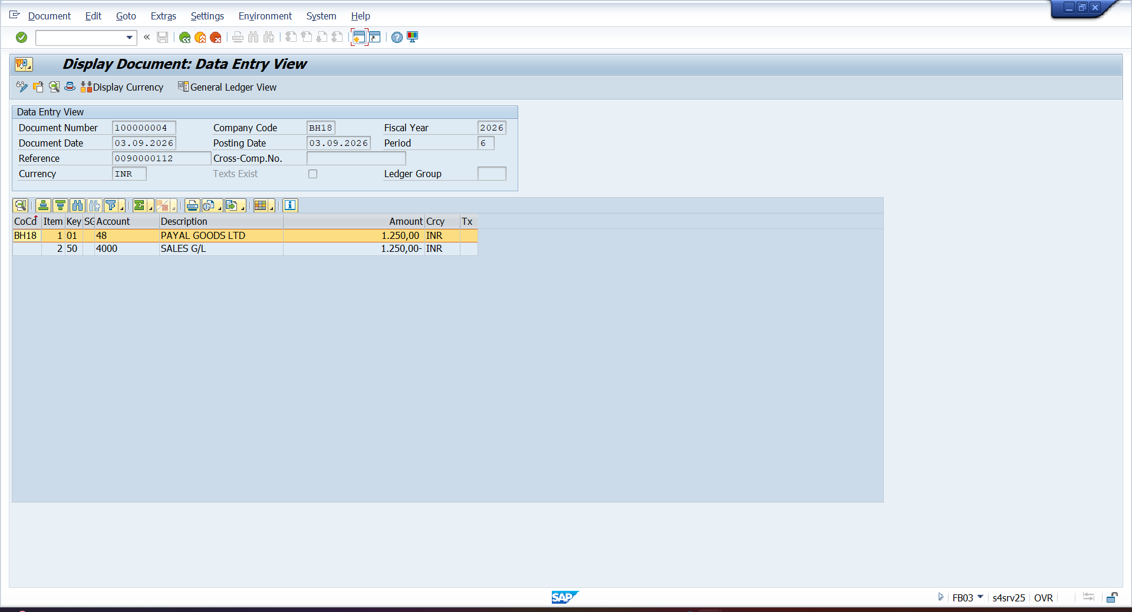

- F-28 – CUSTOMER PAYMENT INVOICE SETTLE AGAINST ADVANCE APYMENT
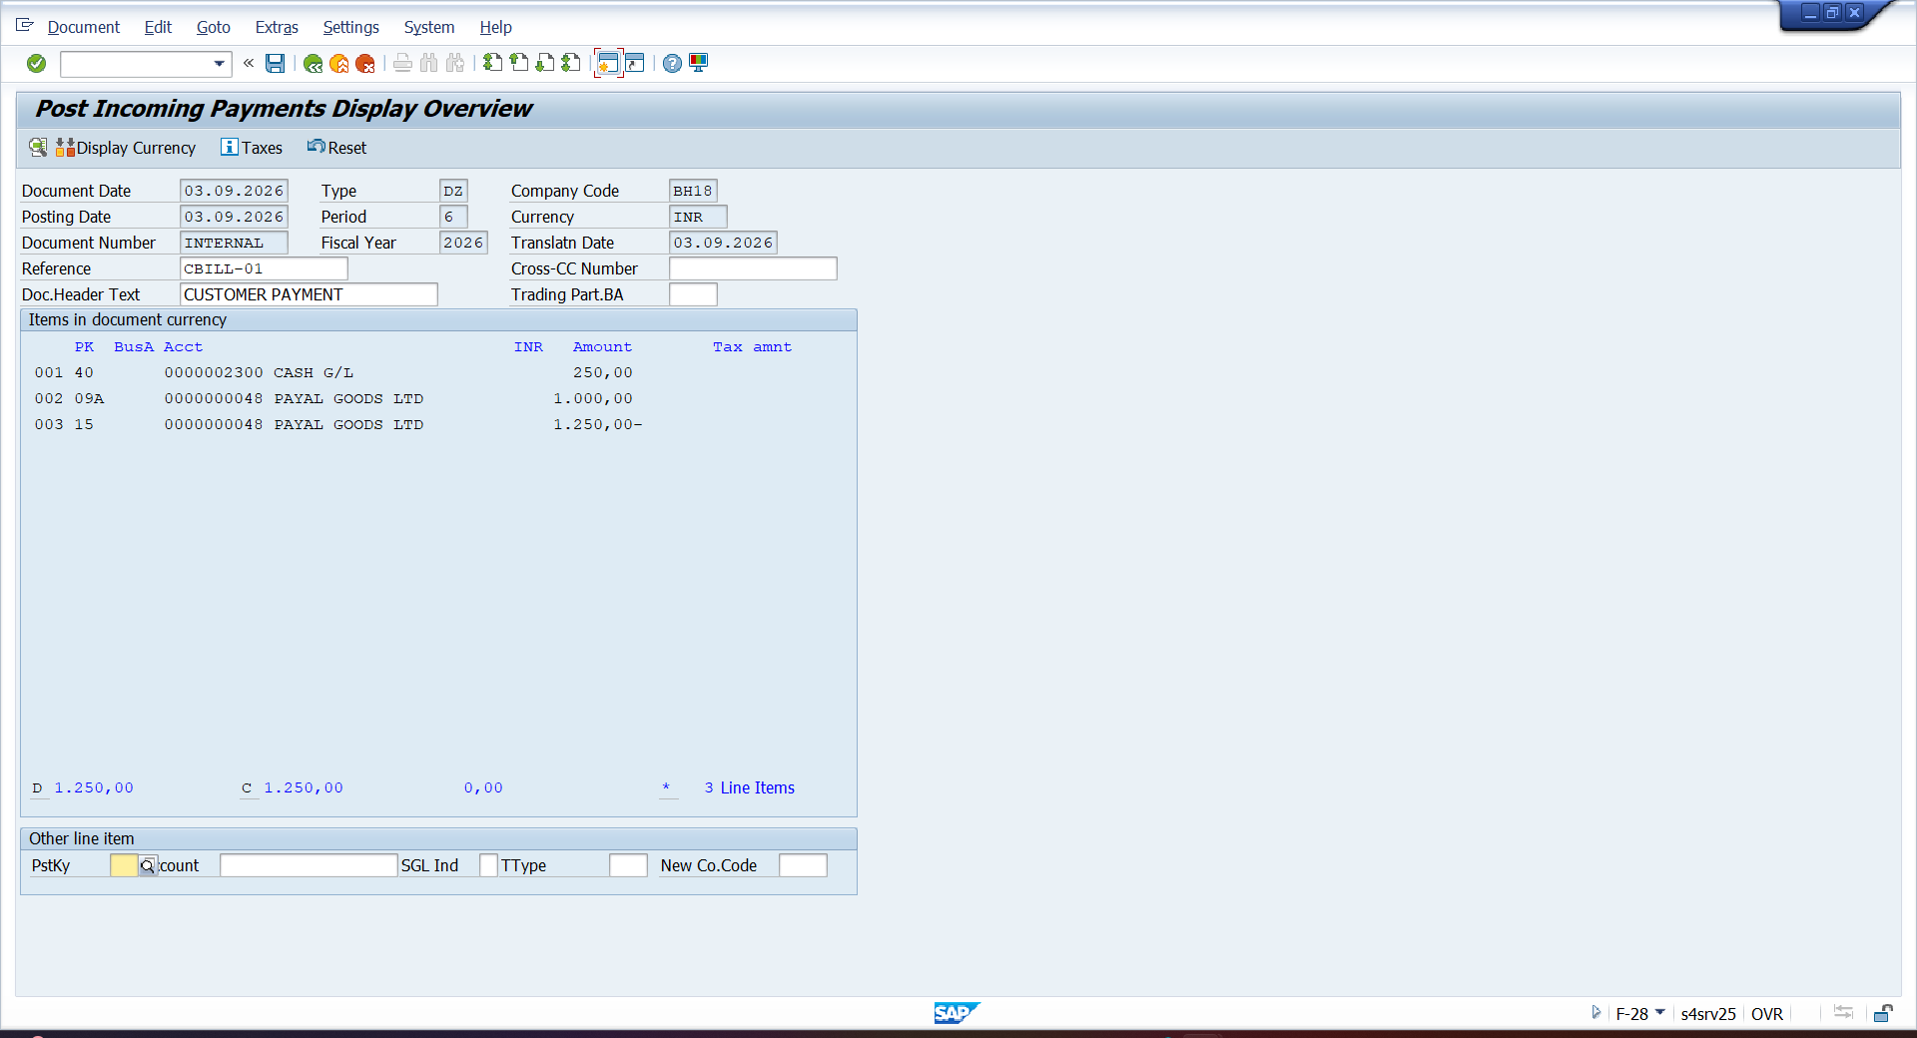

- MB52 – CHECK RECORD
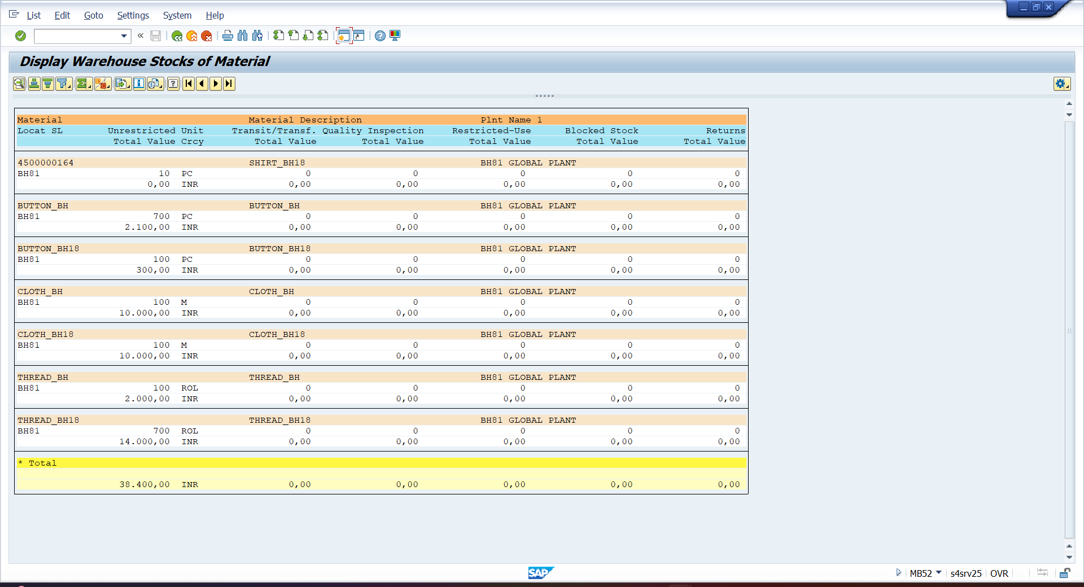

- FBMP – CREATING DUNNING PROCESS
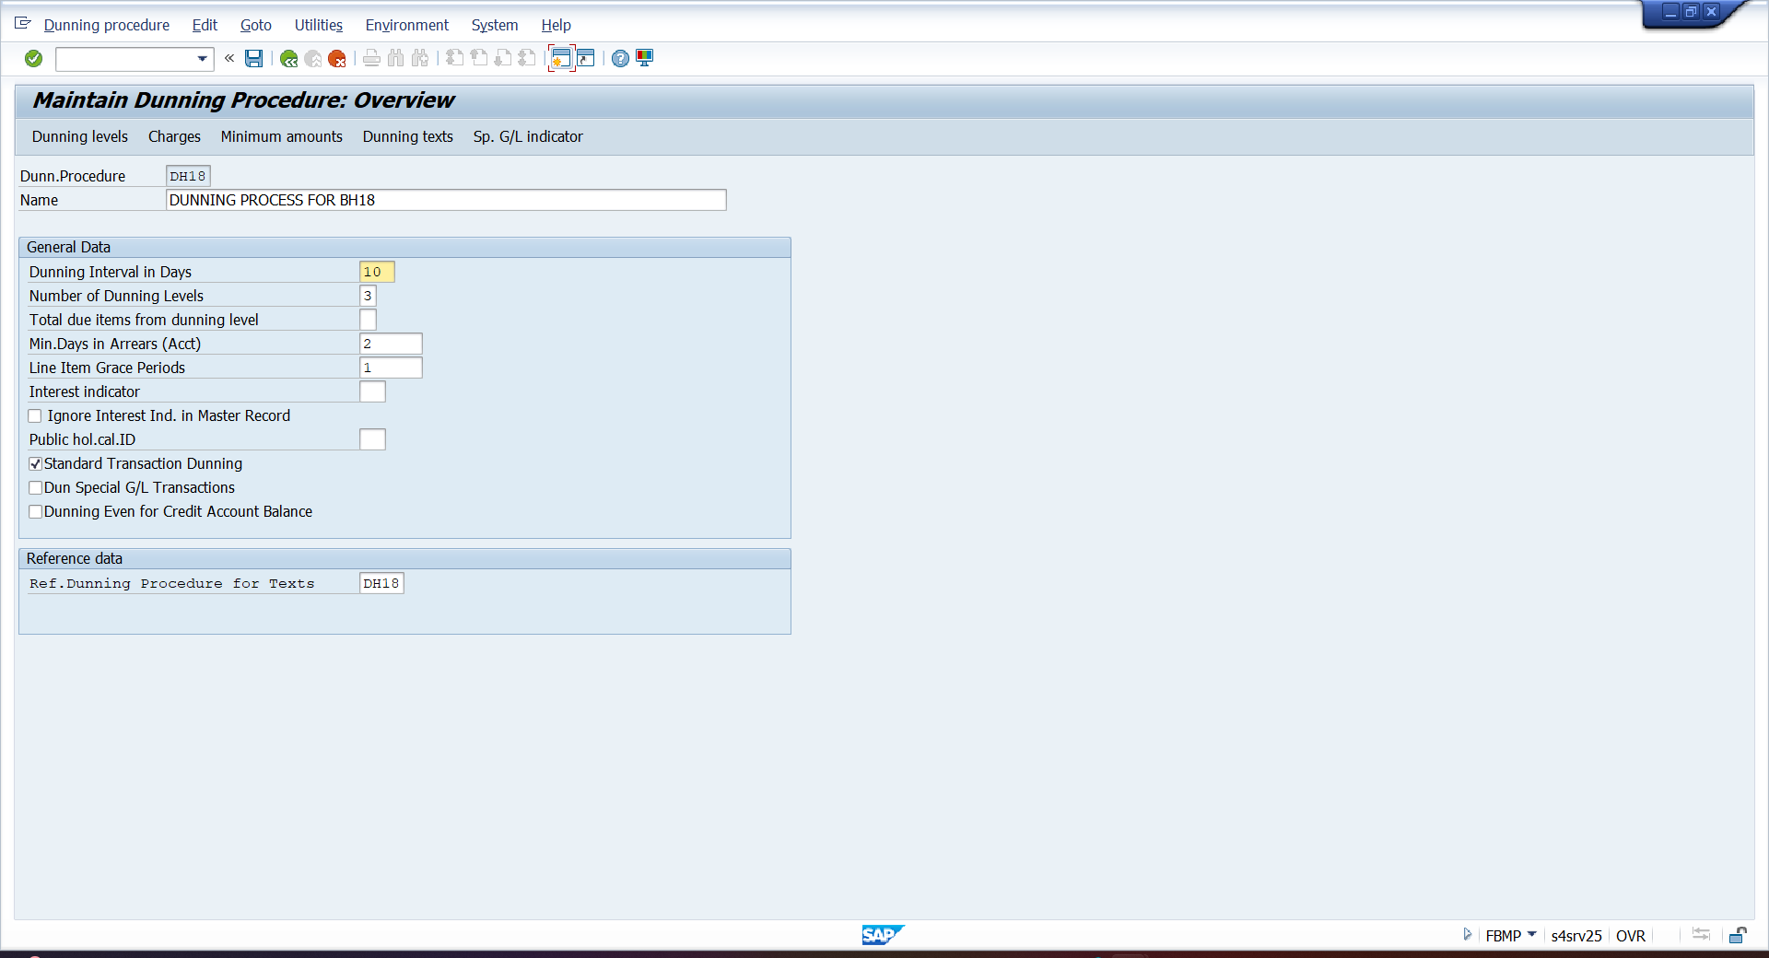

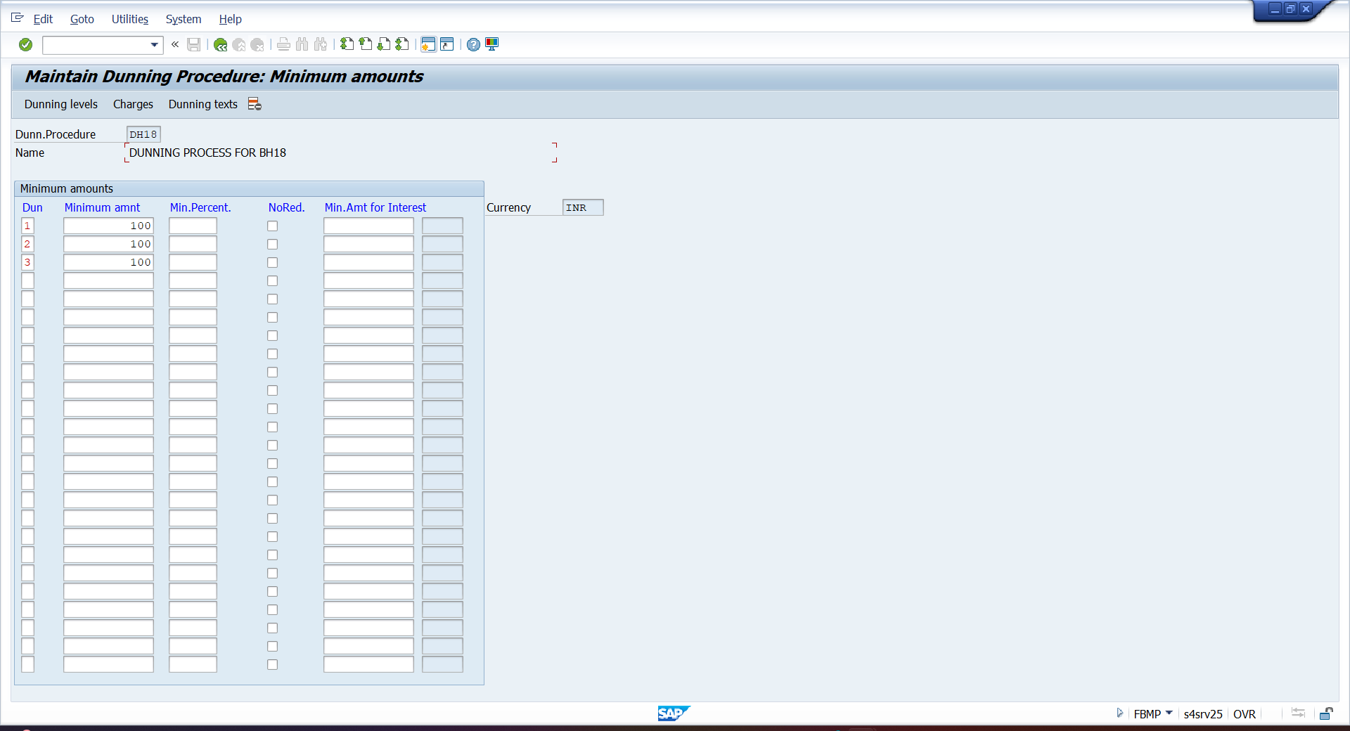

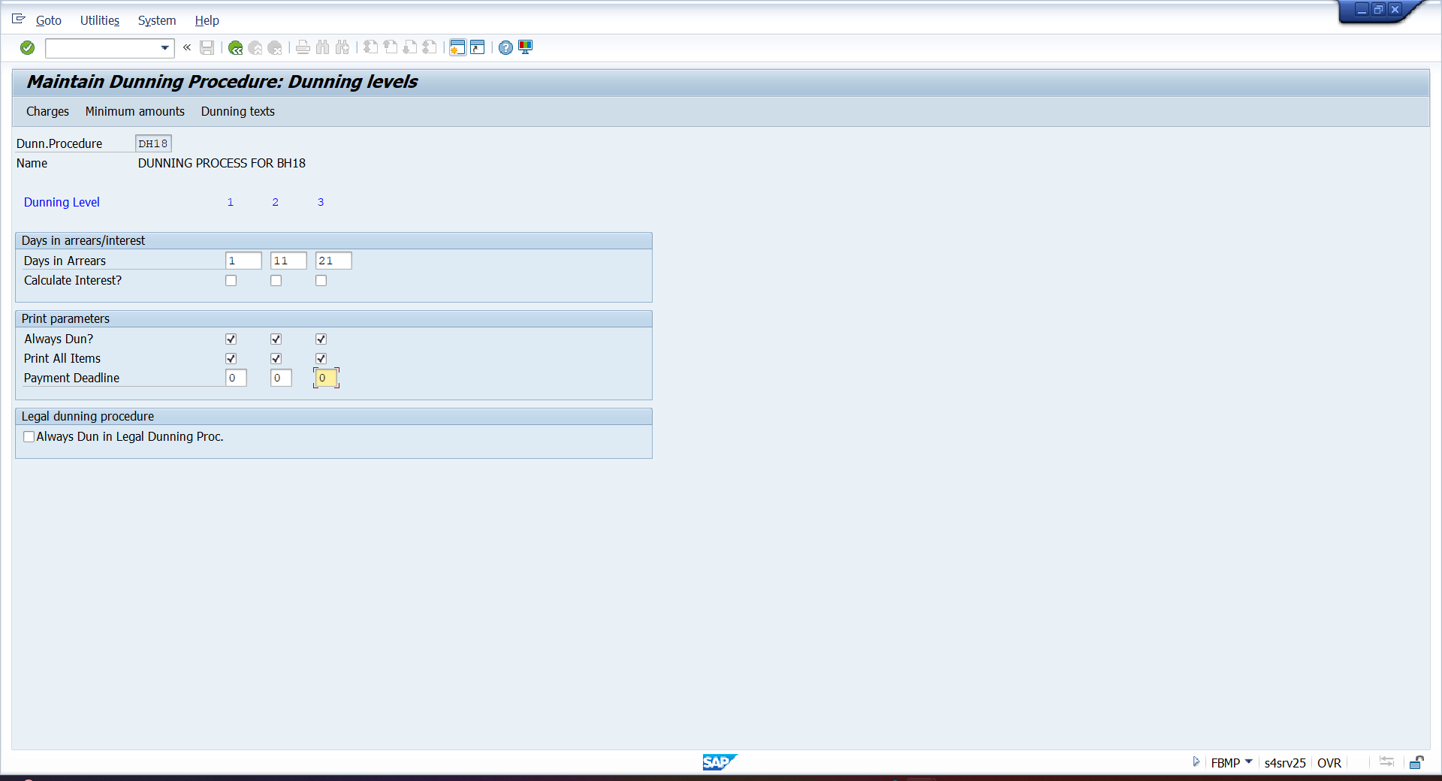

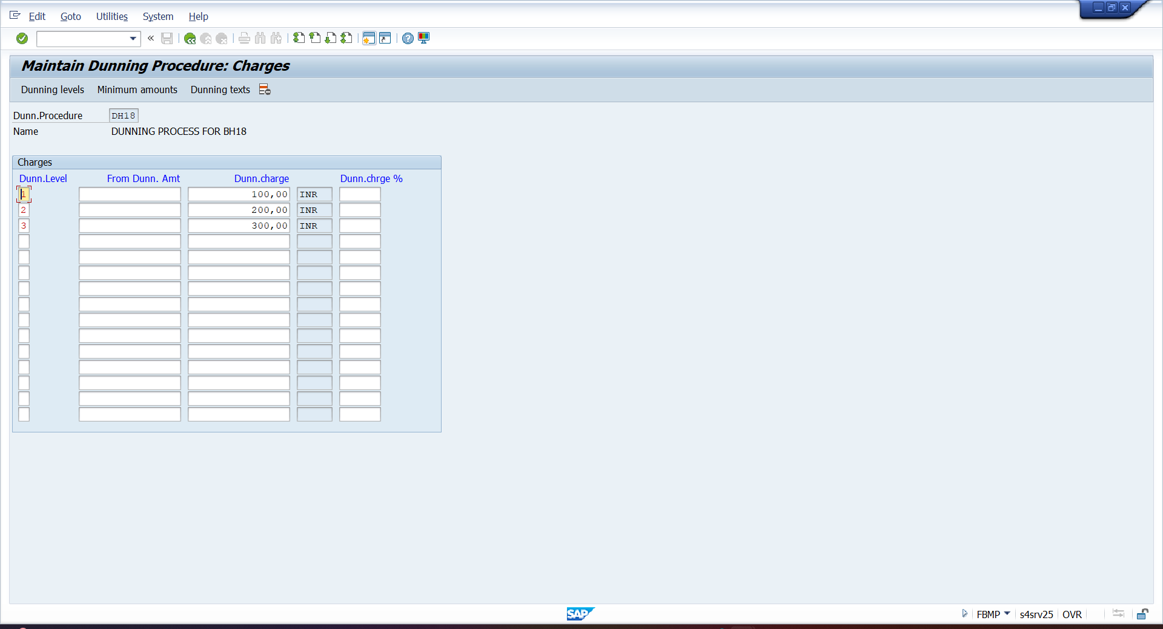

- BP – ASSIGING DUNNING PROCESS TO BP
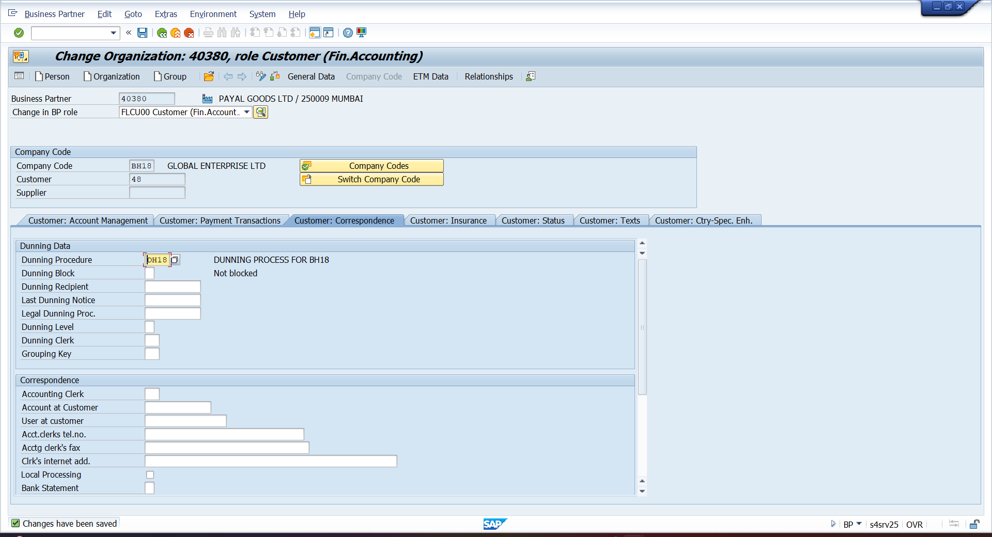

- FBL1N – DISPLAY OVERDUE INVOICE
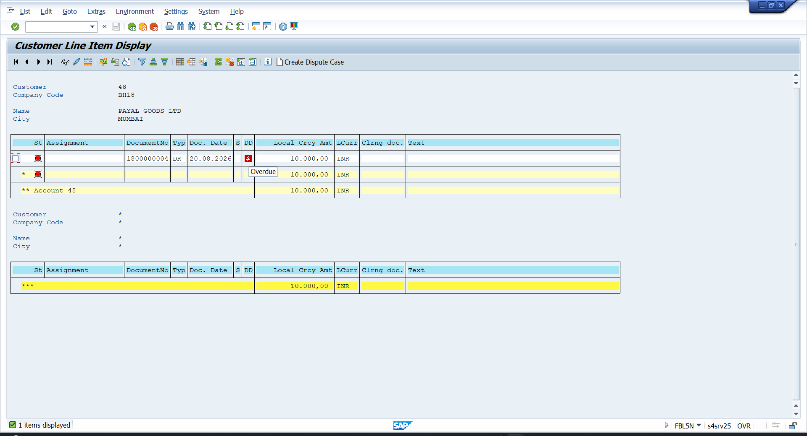

- F150 – RUN DUNNING PROCESS
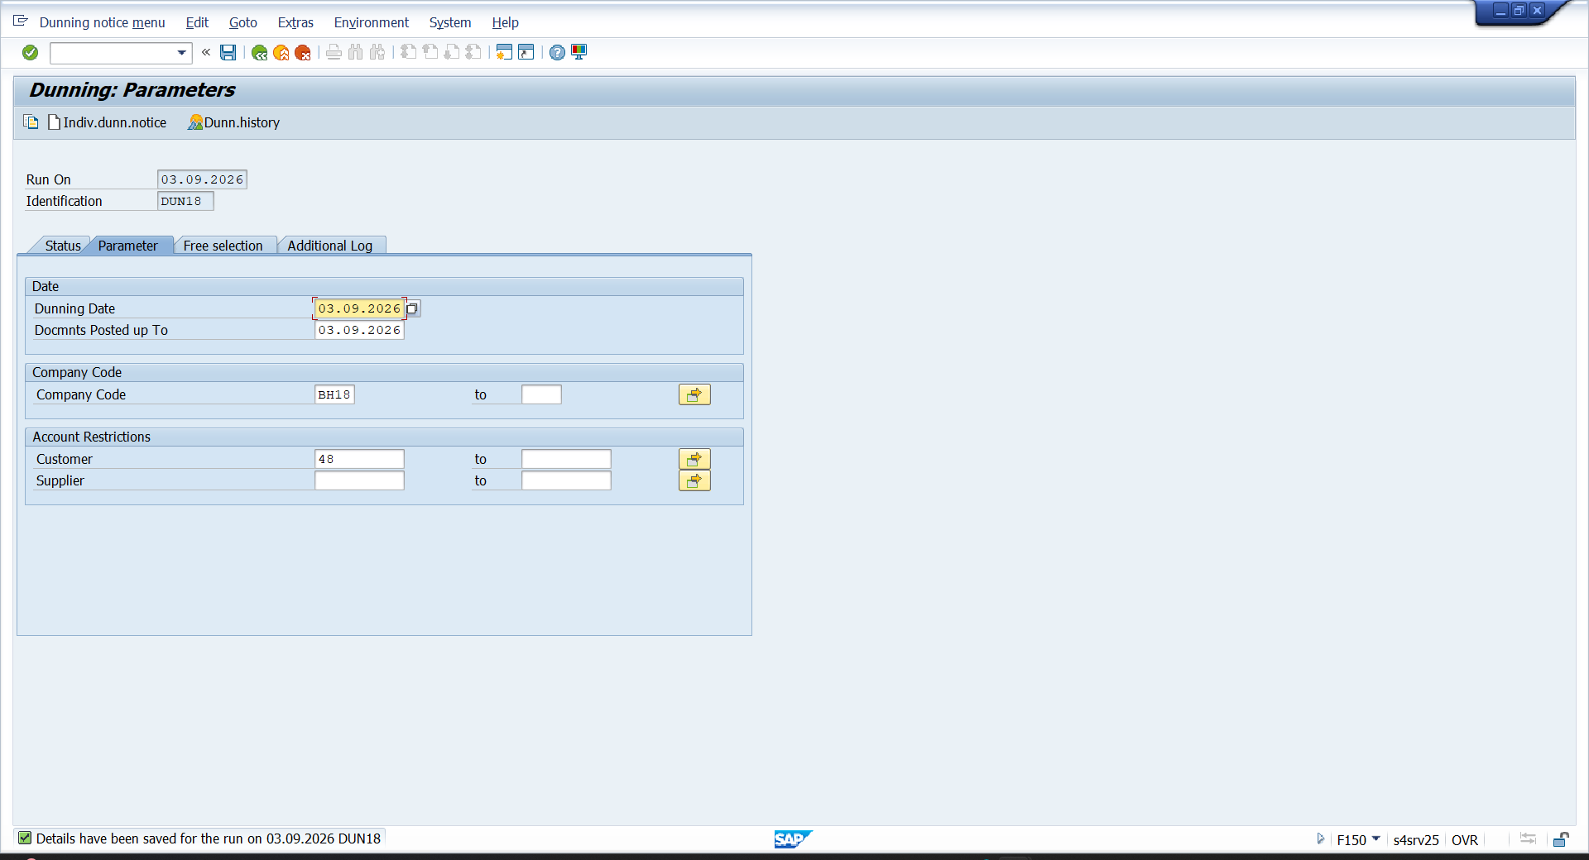

- WARNING LETTER
